Patient Tracker System
Use Case Document


 | Prepared By / Last Updated By | Reviewed By | Reviewed By | Approved By
Name | Nikhil Omar | Kshitij Kumar | Harsh Pradhan | Prateek Kasera
Role | Team Member | Team Member | Team Member | Scrum Master
Signature | Nikhil Omar | Kshitij Kumar | Harsh Pradhan | Prateek Kasera
Date | 4/12/2019 | 4/12/2019 | 4/12/2019 | 4/12/2019

Table of Contents
1.0 Introduction 3
1.1 Purpose & Scope of the document 3
1.2 Intended Audience 3
1.3 Use case ‘Admin Registration’ 3
1.3.1 Use case attributes 3
1.3.2 Use Case Model 4
1.3.3 Business Rules 4
1.3.4 UI Requirements 5
1.3.5 UI Field Validations 6
1.4 Use case ‘Admin Credential Authentication’ 6
1.4.1 Use case attributes 6
1.4.2 Use Case Model 8
1.4.3 Business Rules 8
1.4.4 UI Requirements 8
2.0 Database Design 9
2.1 Tables Structure 9
3.0 Change Log 15

Introduction

Purpose & Scope of the document
The purpose of this Use case document is to systematically capture requirements for the project and the system to be developed in terms of use cases. Functional use cases are captured in this document. It also serves as the input for the project scoping.

The scope of this document is limited to addressing the use cases from a Admin, quality, and non-functional perspective.

Intended Audience
Each member of the project team

Use case ‘Admin Registration’

Use case attributes
Use Case Description:

This use case deals with the capture of Admin details. The ‘Admin’ here shall be the operator of the system and will be keying in the patient information into the system.

Scope:

- Admin registration

Actors:

- Admin – the operator

Trigger:

Click ‘Submit’ button in the ‘Admin Registration’ page

Pre-Condition:

Admin being able to access the homepage & get redirected to the ‘Admin Registration’ page upon click of ‘Register if new’ link.

Post Condition:

Admin is in the enrollment page & submit details

Flow of Events:

Admin at homepage → Click ‘Register if new’ link → Admin is in the enrollment page → Admin details are submitted and added onto the database

Primary Scenario:
A new Admin – is able to click ‘Register if new’ link and able to provide his details and get enrolled in the system.

Use Case Model
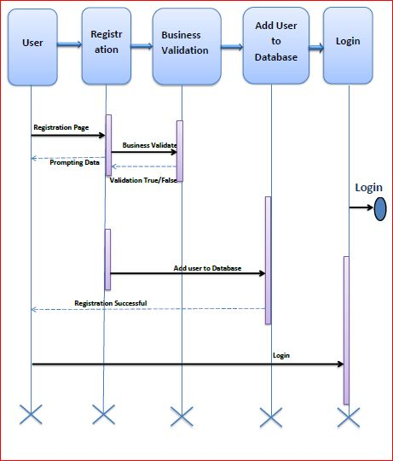

Business Rules

Business rules should be defined using the following attributes: -

- When the Admin clicks on the registration link, it should re-direct to registration form.
    - Admin needs to fill some of the basic attributes/fields as mentioned below in requirement: First Name, Last Name, Age, Gender, Contact Number, Admin Id, Password
- Clicking ‘Submit’ should validate the datatype constraints for each field
- Post-successful field level validation, save the information in the database
- Upon saving the information in the database, display the message ‘Your details are submitted successfully’.

UI Requirements
Here is a prototype on how the homepage should look like.

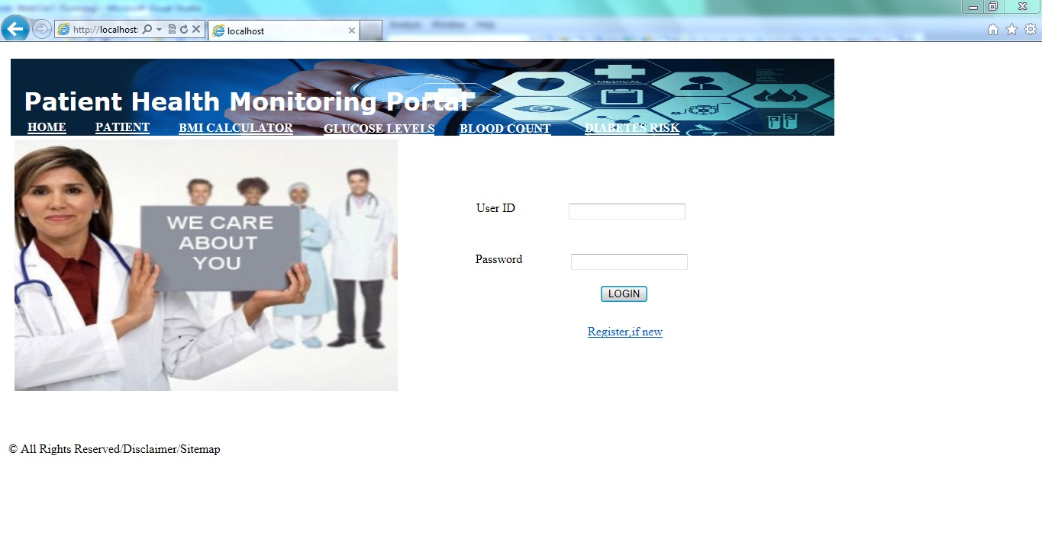

Here is a prototype on how the ‘Admin Registration’ page should look like.

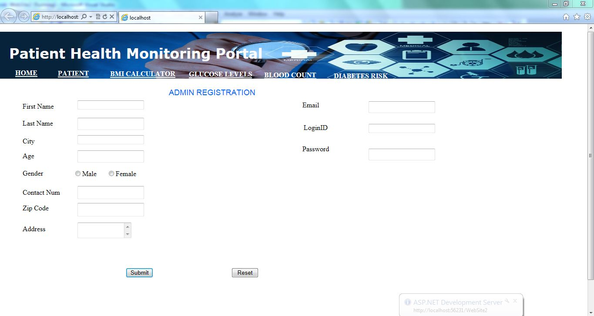

UI Field Validations
Please refer to the below requirements for field level validations:

- All fields are mandatory.
- Username should be less than 30 chars. Password should have minimum 8 chars, no space & can contain special characters (ex. !,@,#,%,*,& etc.)
- Password and Confirm Password fields should be the same
- The Email ID format must be checked. (For ex. test@testmail.com.)
- Phone Number must be of 10 digits’ length(starting from 7,8,9)

Use case ‘Admin Credential Authentication’

Use case attributes
Use Case Description:

This use case deals with the authentication of the Admin credentials. The ‘Admin’ here shall be the operator of the system and will be keying in the information of all entities into the system.

Scope:

- Admin credentials authentication

Actors:

Admin – the operator

Trigger:

Click ‘Login’ link, after keying in ‘AdminID’ & ‘Password’ field.

Pre-Condition:

Admin being able to access the homepage

Post Condition:

Admin is in the Home page

Flow of Events:

Admin at homepage → Key in ‘AdminID’ & ‘Password’ field → Admin credentials are validated → Home page is displayed

Primary Scenario:
A registered Admin – is able click ‘Login’ link, after keying in ‘AdminID’ & ‘Password’ field and get his credentials authenticated with the existing database entry.

Alternative Scenario:
A registered Admin – is able click ‘Login’ link, after keying in ‘AdminID’ & ‘Password’ field and unable to get his credentials authenticated. The Admin is presented with relevant error messages:

- Invalid Admin ID – ‘The Userid provided does not exist in our records’
- Incorrect Password – ‘Password provided is incorrect. Please reach out to your system admin.’

Use Case Model

Business Rules
Business rules should be defined using the following attributes:-

- A registered Admin – is able click ‘Login’ link, after keying in ‘UserID’ & ‘Password’ field and get his credentials authenticated with the existing database entry.

UI Requirements
Here is a prototype on how the patient registration should look like.

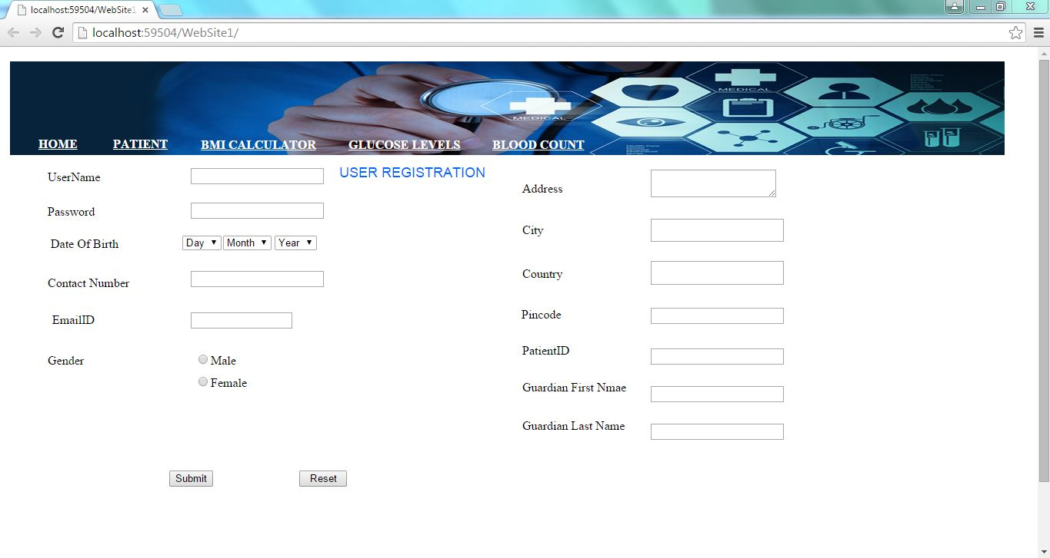

Database Design

Tables Structure
Admin Registration:
Column Name | Data Type | Length | Nulls
Admin Id | nvarchar | 50 | N
Password | nvarchar | 50 | N
First Name | nvarchar | 50 | N
Last Name | nvarchar | 50 | N
Age | int | 5 | N
Gender | varchar | 10 | N
Contact Number | varchar | 10 | N
Email | nvarchar | 50 | N
Dob | nvarchar | 50 | N
Alt.Contact Number | nvarchar | 50 | Y
Password | nvarchar | 50 | N

Patient Registration:
Column Name | Data Type | Length | Nulls
Patient Id | nvarchar | 10 | N
First Name | nvarchar | 50 | N
Last Name | nvarchar | 50 | N
Date Of Birth | date |  | Y
Email Address | nvarchar | 50 | N
Contact Number | varchar | 10 | N
Address line1 | nvarchar | 250 | N
City | nvarchar | 50 | N
State | nvarchar | 50 | N
Zipcode | varchar | 10 | N
Gender | varchar | 10 | N
Address line 2 | nvarchar | 250 | Y
Alt. Contact Number | nvarchar | 50 | Y

Doctor Registration:
Column Name | Data Type | Length | Nulls
Doctor Id | nvarchar | 10 | N
First Name | nvarchar | 50 | N
Last Name | nvarchar | 50 | N
Date Of Birth | date |  | Y
Email Address | nvarchar | 50 | Y
Contact Number | varchar | 10 | N
Address line1 | nvarchar | 250 | N
City | nvarchar | 50 | N
State | nvarchar | 50 | N
Zipcode | varchar | 10 | N
Gender | varchar | 10 | N
Address line 2 | nvarchar | 250 | Y
Alt. Contact Number | nvarchar | 50 | Y
Degree | varchar | 50 | N
Speciality | Varchar | 50 | N
Work Hours | Varchar | 50 | N

Clerk Registration:
Column Name | Data Type | Length | Nulls
Clerk Id | nvarchar | 10 | N
First Name | nvarchar | 50 | N
Last Name | nvarchar | 50 | N
Date Of Birth | date |  | Y
Email Address | nvarchar | 50 | N
Contact Number | varchar | 10 | N
Address line1 | nvarchar | 250 | N
City | nvarchar | 50 | N
State | nvarchar | 50 | N
Zipcode | varchar | 10 | N
Gender | varchar | 10 | N
Address line 2 | nvarchar | 250 | Y
Alt. Contact Number | nvarchar | 50 | Y

Prescription :
Column Name | Data Type | Length | Nulls
Request Id | nvarchar | 10 | N
Patient Id | nvarchar | 50 | N
Doctor Id | nvarchar | 50 | N
Request date | date |  | N
Medicine Id1 | nvarchar | 50 | N
Quantity 1 | nvarchar | 10 | N
Medicine Id2 | nvarchar | 50 | Y
Quantity 2 | nvarchar | 50 | Y
Medicine Id3 | nvarchar | 50 | Y
Quantity 3 | nvarchar | 50 | Y
Medicine Id4 | varchar | 10 | Y
Quantity 4 | nvarchar | 250 | Y
Medicine Id5 | nvarchar | 50 | Y
Quantity 5 | Nvarcher | 50 | Y
Other Info | Varcher | 100 | Y
Status | Varcher | 50 | N

Medicine Registration:
Column Name | Data Type | Length | Nulls
Medicine Id | nvarchar | 10 | N
Medicine Description | varchar | 200 | N
Cure for | varchar | 100 | N
Manufacturing Company | Varcher | 100 | N
Dosage | nvarchar | 50 | N
Prescribed for | varchar | 50 | N
Amount | nvarchar | 250 | N

Bill Generation :
Column Name | Data Type | Length | Nulls
Bill Id | nvarchar | 10 | N
Patient Id | nvarchar | 50 | N
Doctor Id | nvarchar | 50 | N
Bill date | date |  | N
Medicine Id1 | nvarchar | 50 | N
Quantity 1 | nvarchar | 10 | N
Amount1 | Nvarchar | 50 | N
Medicine Id2 | nvarchar | 50 | Y
Quantity 2 | nvarchar | 50 | Y
Amount 2 | Nvarchar | 50 | Y
Medicine Id3 | nvarchar | 50 | Y
Quantity 3 | nvarchar | 50 | Y
Amount 3 | Nvarchar | 50 | Y
Medicine Id4 | varchar | 10 | Y
Quantity 4 | nvarchar | 250 | Y
Amount 4 | Navarchar | 20 | Y
Medicine Id5 | nvarchar | 50 | Y
Quantity 5 | Nvarcher | 50 | Y
Amoount5 | nvarcher | 20 | Y
Total Amount | nvarchar | 50 | N

Change Log
Version Number | Changes Made
V1.0 | Initial baseline created on <dd-Mon-yy> by <Name of Author>
V1.1 | <Please refer the configuration control tool / change item status form if the details of changes are maintained separately. If not, the template given below needs to be followed>
V1.1 | Section No. | Changed By | Effective Date | Changes Effected

